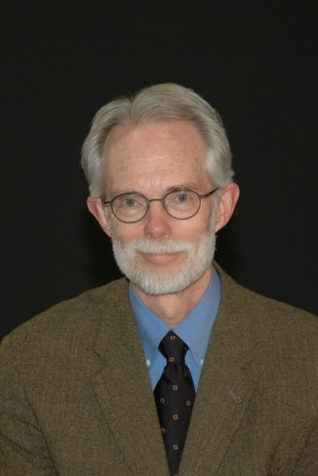

Daniel P. Lammertse, MD,

Emeritus Clinical Scientist, Craig Hospital, Englewood, Colorado
Clinical Professor of Physical Medicine & Rehabilitation, University of Colorado School of Medicine

Dr. Lammertse is the former Medical Director of Research at Craig Hospital in Englewood, Colorado, having retired from his work at that institution in 2016 after 35 years of service. Dr. Lammertse received his M.D. from Ohio State University in 1976 where he also completed his residency training in the Department of Physical Medicine in 1979. He is board certified in Physical Medicine and Rehabilitation (ABPM&R) and the sub-specialty of Spinal Cord Injury Medicine. He has served on the Board of Directors of the American Paraplegia Society (APS) and the American Spinal Injury Association (ASIA). He served as President of ASIA from 2001-2003. He was co-project director of the Rocky Mountain Regional Spinal Injury System from 1997-2016 and served as chair of the National Institute on Disability Rehabilitation and Research (NIDRR) SCI Model Systems Project Directors from 2000-2006. He has served on the Editorial Board of the Journal of Spinal Cord Medicine and was a member of the Spinal Cord Injury Medicine Examination Committee of the American Board of Physical Medicine & Rehabilitation. He has been awarded the American Paraplegia Society Excellence Award in 2008 and the American Spinal Injury Association Lifetime Achievement Award in 2012. Dr. Lammertse has an appointment as Clinical Professor of Physical Medicine & Rehabilitation at the University of Colorado. He currently serves on the Craig H. Neilsen Foundation Board of Directors and is a founding member of the Spinal Cord Outcomes Partnership Endeavor (SCOPE). He is an internationally recognized as an expert in spinal cord injury clinical care and rehabilitation who has authored numerous scientific publications on topics in spinal cord injury, including ventilator-dependent tetraplegia, aging in persons with SCI, and the conduct of clinical trials in SCI.

